DATA FLOW DIAGRAM (DFD)
Online Electricity Bill Payment Platform
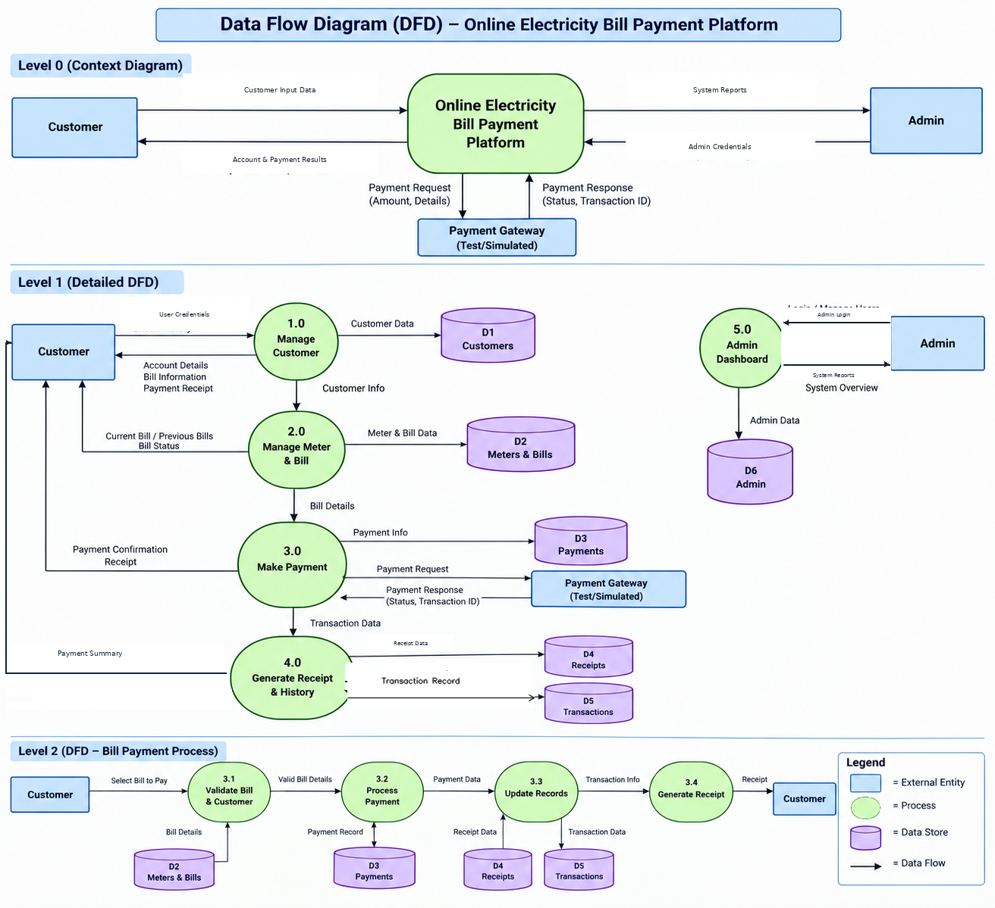
DFD Overview
The Data Flow Diagram shows how information moves between the Customer, Admin, the Online Electricity Bill Payment Platform, the simulated payment gateway, system processes, and data stores. It presents the context, the detailed processes, and the bill-payment workflow.
Errors Faced: DFD Balancing
One error faced was DFD balancing. Example: Process 4.0 (Generate Receipt & History) had an unclear return flow to the Customer and an extra line near D5 (Transactions). The unnecessary line was removed, and the Transaction Record flow is shown clearly toward D5.

